**Name: _________________________________**



**Task 10:**

SOURCE ANALYSIS, FORTNIGHTLY TASK FIVE **Weighting 2% (9 Marks)**

**Question 1**

1. **Explain** the historical context of Source 1. Include the relevant events, people and ideas depicted or represented in the source.

***(4 marks)***

1. Compare and Contrast the purpose of **Sources 1** and **2**. ***(5 marks)***

**Source Booklet:**

**Source 1:**

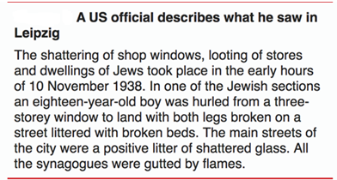

**Source 2:**

